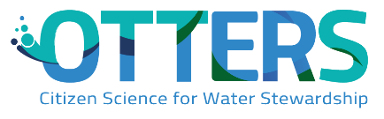


ROADMAP FOR OTTERS IN SCHOOLS
Name of school

Nº of students:

Age/school level of students:

Teachers involved
NAME | SUBJECT DOMAIN | SCHOOL LEVEL

Other stakeholders involved (E.g. other school staff, external partners, families, etc.)
NAME | ORGANISATION | ROLE IN THE PROJECT

Introduction
This document aims to be a guide for those planning OTTERS activities (or any other Citizen Science project) in the educational context. It guides educators in all the necessary steps to ensure a meaningful, effective and well-planned project, involving cocreation with students. Educators are free to modify it and to delete all instructions when they finish their projects (including this introduction), leaving only their ideas and plans. The methodology used is Design Thinking, which leads us through four phases of project development: Feel, Imagine, Create and Share. In the Annex I a template for the final project design can be found.

PLANNING AND COCREATING OUR OTTERS PROJECT

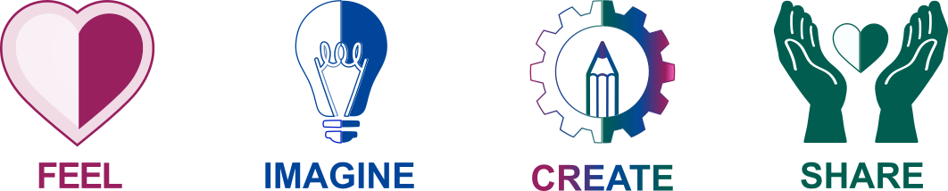
This phase focuses on a deep understanding of what you are going to do. It invites you to reflect on what your motivation is and to outline your goals and objectives. It also encourages you to reflect on who will be involved in this activity and how their needs can be met.

- The water-related issues that we find around our school and in our community:
Explanation of the issue | Level of interest of our students in this issue (for e.g. in a scale from 1 to 5)

- Name of Citizen Science program(s) that respond to these issues:
NAME OF PROGRAM | NUMBER OF VOTES FROM OUR STUDENTS
 | E.g. 15 out of 20 students voted to participate in this program

- Name and e-mail of person(s) we can contact, who are responsible for these programs:
NAME | CONTACT | Have we already contacted them? | Have they answered? (what was the outcome?)

- Learning goals and a meaningful student assessment:
WHAT we can assess and HOW we can assess it?
Recommendation: for each learning goal (content and competences) select at least one adequate tool to collect evidence and an associated metric. See examples below
Learning goal (curriculum content) | Tools we can use to collect evidence | Metrics we can use to assess students:
- E.g.: Curriculum content | - E.g.: games, digital tools like kahoot, Mentimeter, a test, a portfolio, other. | - E.g.: Scale from 1 to 10 and each question has a score

Learning goal (competences to be developed) | Tools we can use to collect evidence | Metrics we can use to assess students:
- E.g.: green competences | - E.g. Observation, Checklists | - E.g.: Rubrics to assess green competences: https://assess.nuclio.org/wp-content/uploads/2024/03/GreenComp_Rubrics-EN-Final.pdf
- Critical Thinking | - E.g. Observation, Checklists | E.g.: Rubrics to assess Critical Thinking, Creativity, etc.: https://assess.nuclio.org/wp-content/uploads/2023/07/Text_rubrics_EN-Final-2.pdf

WHEN we can assess
How frequently we can promote student assessment
E.g.: Collecting evidence through tests, quizzes, kahoot, etc. | E.g.: Once every 3 months
E.g.: Observations | E.g.: Weekly
E.g.: Using the rubrics to assess competences | E.g.: twice a month
E.g.: Promoting students’ self-assessment | E.g.: once a week

- Here you can find a book that inspires and guides teachers towards innovating in the way they assess their students: https://assess.nuclio.org/the-assess-book/
- Here you can find the rubrics to assess competences. The files are in PDF and in Word in case you want to edit them: https://assess.nuclio.org/assessment-toolkit/
- Checklist for a positive and powerful student assessment (check as many as you can):
- We will involve our students in the definition of the learning goals and in the selection of the assessment tools.
- We will make the assessment process transparent by sharing with our students their learning goals as well as the assessment tools and metrics in the beginning of the project (or school year)?
- We will provide regular feedback to our students, to allow them multiple opportunities to improve.
- We will promote self-assessment of our students, using the same metrics that we will use.
- The summative assessment will be generated as a result of the formative assessments and will not be based on one single moment / activity / test.
- We will celebrate mistakes instead of preventing them – we learn a lot from our mistakes!
- We will consider student assessment as a process to promote the self-development and learning of our students and not to compare, judge or criticize them– we grow better with self-awareness and support!

- Write bellow the strategies that you should use to ensure that this project is inclusive and ensures equity in our classrooms:
- E.g.: we will offer the same opportunities to all students, without exception
- E.g.: we will accommodate my students needs in the different phases of the project
- E.g.: we will use multiple means of representation as in the UDL – Universal Design for Learning guidelines
- E.g.: We will listen to the individual needs of students (even if not possible to accommodate them).

- In this document you can find a checklist that will help you to ensure gender balance in your teaching practice: https://assess.nuclio.org/wp-content/uploads/2023/08/Gender-balance-in-education-checklist-ASSESS.pdf

- Here you can learn about the Universal Design for Learning that helps us to design inclusive learning activities by removing barriers that can hinder students’ learning: https://udlguidelines.cast.org

Now that you have reflected on your motivation, your needs and the needs of those involved, in this phase you are invited to activate your imagination and start to ideate how you can carry out this project in your school, considering what you have already defined in the FEEL phase.

- Timeline of this project in our school:
- Project beginning date:
- Project end-date:

- Phases of the project: add below your timeline plan (you can use the diagram below or any other of your choice).

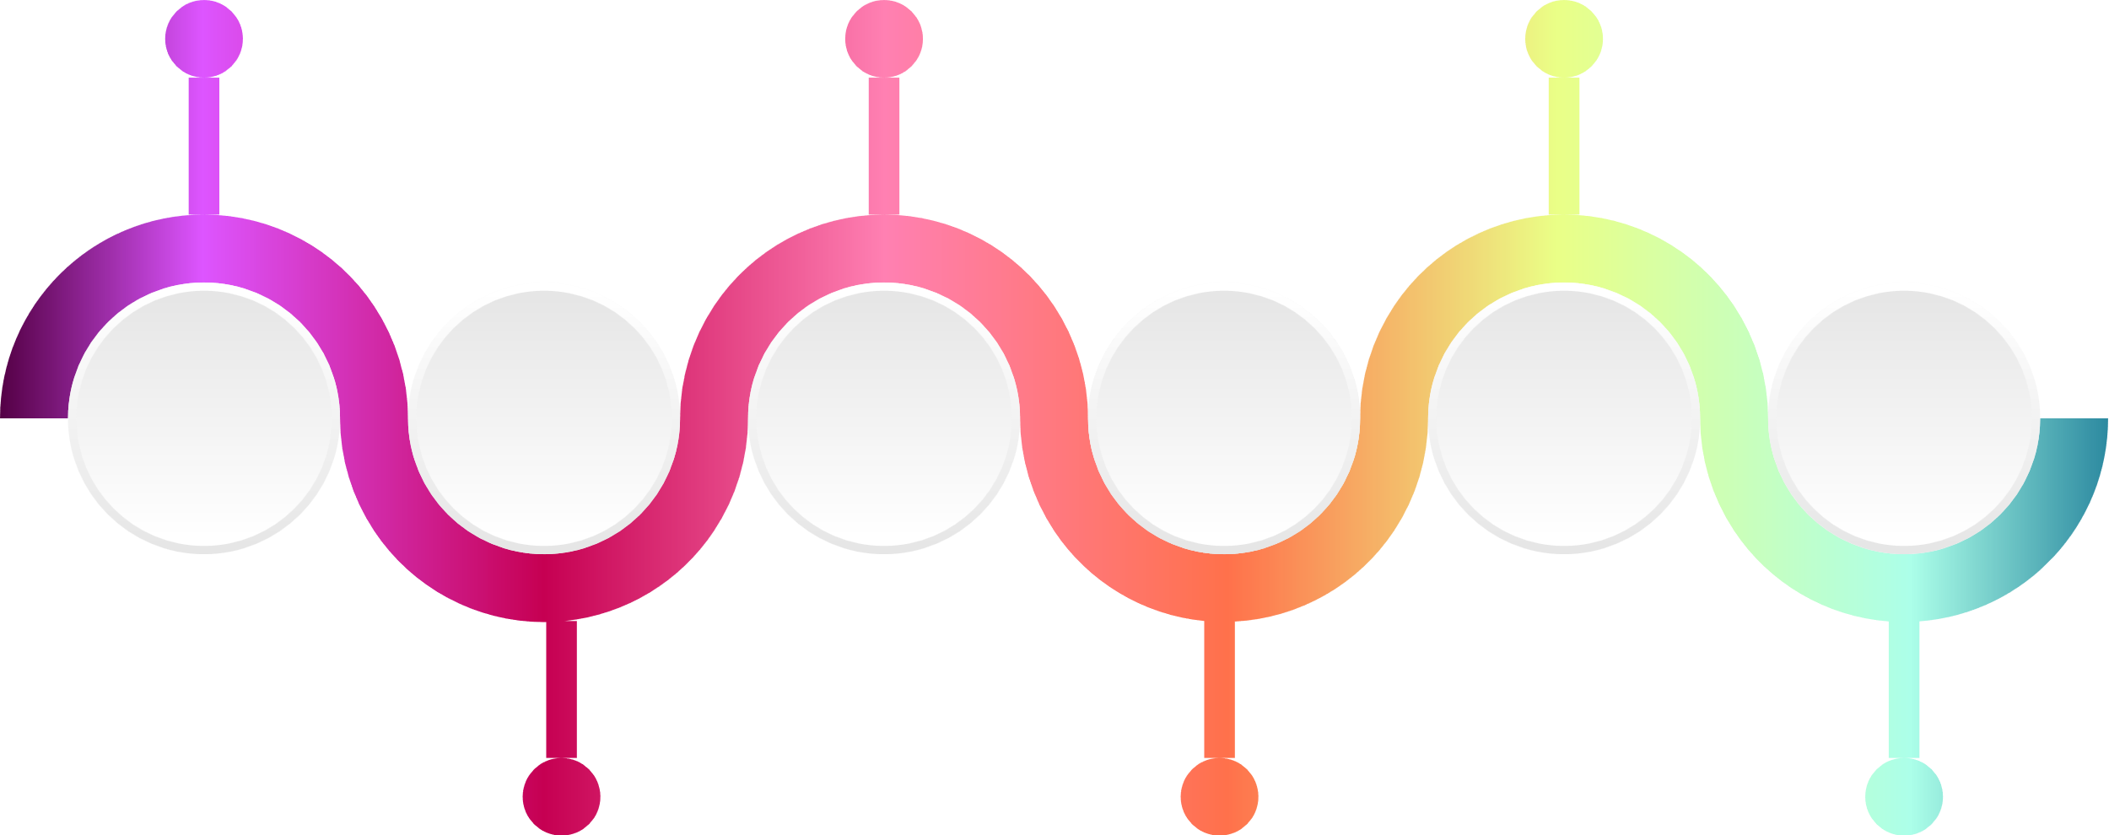

- Interdisciplinarity of this project: To motivate collaboration among teachers and provide students with a bigger picture of what they learn.

Subject domain | Curriculum content | How it is connected to the selected citizen science program, to the identified local issue and to the other subject domains.
E.g.: Chemistry | E.g.: pH of water | E.g.: It relates to the acidity of the ocean, it affects biodiversity (biology), and the rain waters as well, affecting humans, etc.

You can also use a mind-map such as the one below, if you prefer, to structure the interdisciplinarity of your project.

- Ideas from our students that can enrich and/or influence the project implementation
Name of student(s) | Idea and how it will be integrated in the project | This idea was integrated in the project? If not, why?
 | e.g. a video, book, game recommended by a student
 | e.g. a partnership discovered by a student

- Resources at our disposition to use during this project in our school
Resource | Origin/website | How I will use it
E.g. list of available citizen science campaigns  E.g. survey to assess students awareness of environmental issues, etc. | E.g.: OTTERS resource hub or https://eu-citizen.science/

- Ideas to introduce this project to our students in a meaningful way?
Idea | Link/origin/website | Will we use it?
e.g. a vídeo | Youtube | maybe
e.g. Laura’s ppt for WP3 and cocreation questions
- Here you can find more resources and online courses to support your activities:
- Introducing Citizen Science https://moodle.eu-citizen.science/course/view.php?id=9
- Citizen Science in Schools https://moodle.eu-citizen.science/course/view.php?id=19

- Reflecting …
How we can promote in our students an understanding for the importance of Citizen Science and preserving water:

How we can reflect with them on the definition of Citizen Science:

How we can work with them on the ECSA’s 10 principles of Citizen Science:

How will you guide your students in this project? How will you share it with others? This is the moment when all the ideas come together for you to design your OTTERS project with concrete steps to take. While in this document you have added many ideas for your own reflection, in this phase you will select the concrete ideas, tools, methods, that you will use in your practice and create a document to be used and shared with others.
NOTE: Design Thinking is a powerful tool to develop projects, you have used it during this planning phase and your students can use it too! It promotes the development of several competences in students and offers them agency over their learning process. For this reason, we propose that you create a guiding document for your students to follow the four steps of design thinking to develop their own projects.

You can create your final document from scratch, or you can use an existing template to write down your final OTTERS project. You can find a template with guidelines on the ANNEX I of this document. If you create your own, please consider the following:
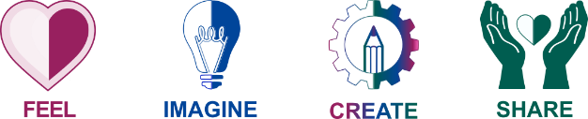In this phase, guide your students into a deep understanding of the theme / problem at hand. Allow them to research on their own, to identify the issues they want to work on, to select the citizen science campaign(s) they will want to be involved in and to learn deeply about the science behind them: the scientific questions and methods.
Guide your students in a brainstorming process, where all ideas are valuable for the solution or improvement of the issues raised in the FEEL phase. All ideas count! Students should write down their ideas and vote on the ones they will work on. This can relate to how they will contribute to the chosen citizen science campaign(s), how they can further solve the problem and/or raise awareness.
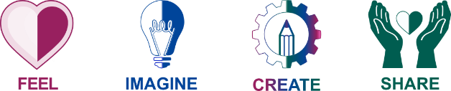In this phase, your students can give life to the ideas selected on the previous phase. This can involve their participation in the citizen science campaign(s), the creation of reports and documents to improve those campaigns, the creation of dissemination materials, etc.
Sharing and reflecting on what was done is one of the most important parts of any project. Encourage your students to tailor their sharing method to their target audience and reach the maximum impact they can.
This is the phase where you (educators) give life to your plans and start working with your students! It is also the moment when you can share your wonderful work with your community! Who do you want to share it with? Maybe with people that can benefit from your achievements? Maybe with other teachers that might want to follow in your footsteps? Sharing is the best and most important part of the process!

- How we will share the guidelines for the project with the students:
  - We will share our created guidelines document and they will autonomously follow it, with our support and assistance
  - We will use the guidelines document and will guide our students step-by-step

- How we will keep a record of our results and achievements:
- E.g. add one more section to this plan to add pictures and register the results
- E.g. make a video

- Who we will share our results with:
Who we will share our results with | How we will share | Outcomes of this sharing process
E.g.: Municipality | E.g.: Through a video | E.g.: They want me to present my work in a conference

ANNEX I – Design Thinking Template for Students’ projects

About the project

Authors of this document:

School name:

Age of students:

Number of students involved:

Title of the project:

Duration of the project:

Brief description (1 to 2 paragraphs):

Other intervenients in this project:

Subject domains involved:

Interdisciplinarity of this project (a short description on how the subject domains will work together to connect to each other and with the project’s theme):

Planning for student assessment

What will be assessed during this project
Curriculum content we expect our students to learn during this project | Competences we expect our students to develop during this project

How students will be assessed
Recommendation: for each learning goal (content and competences) select an adequate tool to collect evidence and an associated metric. See examples below
Learning goal | Tools we can use to collect evidence | Metrics we can use to assess our students:

When students will be assessed
Type of assessment | Frequency

Our OTTERS project with guidelines for students
- FEEL
Support note (you can erase this once you complete this section): This is the moment when your project starts. In this phase, students will be introduced to the theme. The goal is for them to deeply learn about the issue at hand and to deeply understand how it connects to their daily lives and to their communities.

Think of an engaging way to introduce them to the project, in a way that captures their attention and curiosity, ensuring that they will be truly involved in the project throughout its different phases.
This is also when cocreation with students will start. This means that they can be the ones to identify the issues in their community related to water that they want to work on, they can vote on which citizen science program(s) they want to work with and learn the science behind it, including the scientific questions and methods.
In the next phase, they will put their use their imagination to IMAGINE solutions to the problem(s) raised.

Considering this, write down here HOW you will guide your students through this FEEL process, with enough detail that they can follow the steps on their own and for anyone else to replicate this process.

RESULTS OF THE FEEL PHASE:

By the end of your implementation, you can add here results from this phase, including pictures, aha moments, quotes from students and other people involved, etc. This can inspire others to design projects as amazing as yours.

- IMAGINE
Support note (you can erase this once you complete this section): By this moment, your students should already be “specialists” in the theme they will be working on. So, now, it is the time to give wings to their imagination and explore all possible ideas about how to solve the problem.
This can involve solutions to bring awareness into the community, ideas on how to participate and contribute to the chosen citizen science program(s), ideas on how to continue working on the issue after collaborating with the citizen science program, etc.

This phase should open the doors to free ideation and brainstorming. Include guidelines on how to do this process. For example, ask students to work in groups and write down all their ideas, vote on the preferred ideas, etc. Remind students to select ideas that are feasible considering the problem and all those involved in it.
Ensure that all students have the same opportunities to share their ideas and vote.

RESULTS OF THE IMAGINE PHASE:

By the end of your implementation, you can add here results from this phase, including pictures, aha moments, quotes from students and other people involved, etc. This can inspire others to design projects as amazing as yours. You can include here all the ideas from your students. This might help others to solve the problem too.

- CREATE

Support note (you can erase this once you complete this section): In this phase students will give life to their ideas and start developing their solutions. It can relate to the participation in the citizen science program, collecting data, generating data, creating awareness materials, etc.

Write down here guidelines for your students to think about how to plan their projects. How to select the necessary materials, define the steps they will take, who will do what, etc. Ensure that all students have the same opportunities to participate in this phase.

Open the doors to mistakes and encourage students to accept that failing is also an important part of the process.

RESULTS OF THE CREATE PHASE:

By the end of your implementation, you can add here results from this phase, including pictures, aha moments, quotes from students and other people involved, etc. This can inspire others to design projects as amazing as yours. You can include here pictures from their creations too.

- SHARE

Support note (you can erase this once you complete this section): This is the final part of the process and many times one of the most rewarding. Let’s share the work!
This is the moment where whatever your students have created will be shared with others (colleagues, school community, extended community, etc.)
Write here guidelines that support students in identifying who their target audience is, and to prepare their presentation materials (slides, videos, posters, performances, etc.).
Include also a moment for reflection on the results, considering what worked well and what could be improved.

RESULTS OF THE SHARE PHASE:

By the end of your implementation, you can add here results from this phase, including pictures, aha moments, quotes from students and other people involved, etc. This can inspire others to design projects as amazing as yours. You can add here pictures of your students sharing their results and write down final considerations.

